#
# 20181010
# It was conversation in Slack with Shkurina Anastasia

Итого, у тебя есть Админский доступ к четырём Грейлогам (из пяти мне известных):
1. https://ha-graylog.tcsbank.ru
2. https://trading-gl.tcsbank.ru
3. http://graylog.ti.local/system
4. https://pfm-gl.tcsbank.ru

Белогруд Сергей [12:09 PM]
5. http://vm-prt-graylog-srv01.ti.local

На 5-й Грейлог у меня доступа нет. Это, как я понимаю, портальный Грейлог для Страховой. Видимо этим грейлогом заруливают сами страховщики и Леонов Алексей.
Соответственно, при попадании заявок про этот Грейлог - нужно будет просить Леонова создать твою локальную учётку на этом Грейлоге. Или как-то разруливать заявку, чтобы её сделали без твоего участия.

#
# 20180823
#
https://wiki.tcsbank.ru/display/EA/Graylog

# 1. Есть ha-graylog,
# 2. есть GrayLog страховой,
# 3. есть GrayLog страховой портальный,
# 4. есть GrayLog платформы (бывший банковский портал),
# 5. есть тестовый GrayLog (на побаловаться).

#
# Primary balancer place.
# Server in M1 is a primary always.
#

# Here are configs for inputs.
[root@m1-graylog-lb01 ~]# ls -Alh /etc/keepalived/conf.d/ | head
total 660K
-rwx------ 1 root root 174 Aug 22 11:57 reload.sh
-rw-r--r-- 1 root root 610 Apr 11 08:44 tcp-12001-input.conf
-rw-r--r-- 1 root root 1.6K Aug 22 12:10 tcp-12002-input.conf
-rw-r--r-- 1 root root 1.1K Jul 17 10:14 tcp-12003-input.conf
-rw-r--r-- 1 root root 1.6K Aug 22 12:05 tcp-12004-input.conf
-rw-r--r-- 1 root root 1.1K Apr 11 10:05 tcp-12005-input.conf
-rw-r--r-- 1 root root 1.1K Apr 11 10:09 tcp-12006-input.conf
-rw-r--r-- 1 root root 1.1K Apr 11 10:06 tcp-12007-input.conf
-rw-r--r-- 1 root root 1.1K Apr 11 10:07 tcp-12008-input.conf
[root@m1-graylog-lb01 ~]#

[root@m1-graylog-lb01 ~]# ls -A1 /etc/keepalived/conf.d/*tcp* | sort -h | tail
/etc/keepalived/conf.d/tcp-12544-input.conf
/etc/keepalived/conf.d/tcp-12545-input.conf
/etc/keepalived/conf.d/tcp-12546-input.conf
/etc/keepalived/conf.d/tcp-12547-input.conf
/etc/keepalived/conf.d/tcp-12548-input.conf
/etc/keepalived/conf.d/tcp-12549-input.conf
/etc/keepalived/conf.d/tcp-12900-graylog-rest.conf
/etc/keepalived/conf.d/tcp-1514to12600-input.conf
/etc/keepalived/conf.d/tcp-443-graylog-web.conf
/etc/keepalived/conf.d/tcp-80-graylog-web.conf
[root@m1-graylog-lb01 ~]#

[root@m1-graylog-lb01 ~]# cat /etc/keepalived/conf.d/tcp-12549-input.conf
virtual_server 10.216.40.170 12549 {
delay_loop 6
lb_algo rr
lb_kind NAT
protocol TCP

real_server 10.217.26.8 12549 {
weight 1
SSL_GET {
url {
path /api/system/lbstatus
status_code 200
}
connect_port 443
connect_timeout 2
}
}

real_server 10.217.26.7 12549 {
weight 1
SSL_GET {
url {
path /api/system/lbstatus
status_code 200
}
connect_port 443
connect_timeout 2
}
}
}
[root@m1-graylog-lb01 ~]#

[root@m1-graylog-lb01 ~]# ls -A1 /etc/keepalived/conf.d/*udp* | sort -h | tail
/etc/keepalived/conf.d/udp-12424-input.conf
/etc/keepalived/conf.d/udp-12455-input.conf
/etc/keepalived/conf.d/udp-12456-input.conf
/etc/keepalived/conf.d/udp-12457-input.conf
/etc/keepalived/conf.d/udp-12458-input.conf
/etc/keepalived/conf.d/udp-12459-input.conf
/etc/keepalived/conf.d/udp-12460-input.conf
/etc/keepalived/conf.d/udp-12461-input.conf
/etc/keepalived/conf.d/udp-12462-input.conf
/etc/keepalived/conf.d/udp-8702-input.conf
[root@m1-graylog-lb01 ~]#

[root@m1-graylog-lb01 ~]# cat /etc/keepalived/conf.d/udp-12462-input.conf
virtual_server 10.216.40.170 12462 {
delay_loop 6
lb_algo rr
lb_kind NAT
protocol UDP

real_server 10.217.26.7 12462 {
weight 1
SSL_GET {
url {
path /api/system/lbstatus
status_code 200
}
connect_port 443
connect_timeout 2
}
}

real_server 10.217.26.8 12462 {
weight 1
SSL_GET {
url {
path /api/system/lbstatus
status_code 200
}
connect_port 443
connect_timeout 2
}
}
}
[root@m1-graylog-lb01 ~]#

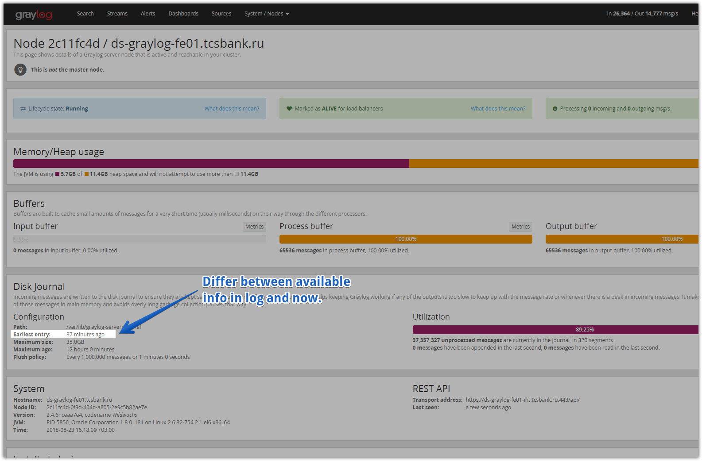

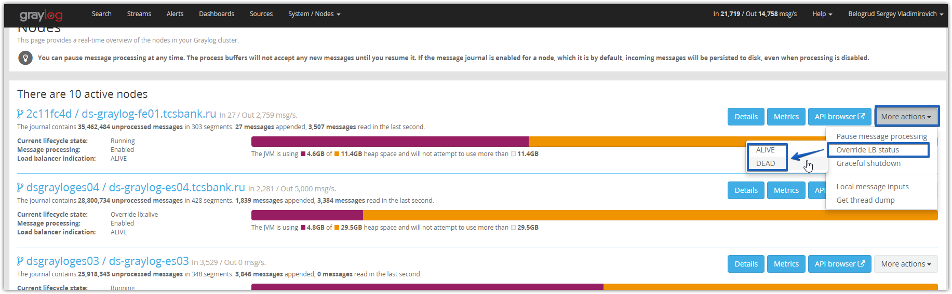

[s.belogrud@TCS4357]# curl -s -XGET http://ds-graylog-es04:9200/_cat/health?v
epoch timestamp cluster status node.total node.data shards pri relo init unassign pending_tasks max_task_wait_time active_shards_percent
1535032268 16:51:08 graylog-tinkoff green 7 7 19102 9551 12 0 0 0 - 100.0%
[s.belogrud@TCS4357]#

[root@vm-vol-nag4-tst objects]# curl -s -XGET http://ds-graylog-es04:9200/_nodes/stats |jq ".nodes[] | {name: .name, bulk: .thread_pool | .bulk}"
{
"name": "ds-graylog-es02.tcsbank.ru",
"bulk": {
"threads": 32,
"queue": 0,
"active": 0,
"rejected": 0,
"largest": 32,
"completed": 58203838
}
}
{
"name": "ds-graylog-es04.tcsbank.ru",
"bulk": {
"threads": 32,
"queue": 0,
"active": 0,
"rejected": 0,
"largest": 32,
"completed": 57941104
}
}
...

[s.belogrud@TCS4357]# curl -s -XGET http://ds-graylog-es04:9200/_cat/indices?v
health status index pri rep docs.count docs.deleted store.size pri.store.size
green open ti_esb_prod__222 12 1 53856478 0 261.4gb 130.8gb
green open smeiwprod__349 4 1 55196 0 68mb 34mb
green open ti_esb_prod__223 12 1 54079487 0 254gb 126.9gb
green open ti_esb_prod__220 12 1 57206328 0 272.6gb 136.3gb
green open tinkoff_info_80 6 1 0 0 1.8kb 955b
green open ti_esb_prod__221 12 1 55453181 0 262.3gb 131.1gb
green open smeiwprod__341 4 1 16679 0 33.6mb 16.8mb
...

Graylog Collector Sidecar
http://docs.graylog.org/en/2.4/pages/collector_sidecar.html

